# BookMe

**Basic Wireframe for Leeds team** – User based pages are not defined as we will have different thoughts in the idea of displaying floor/seat etc.

**Pages/routes anticipating** –

1 - Site landing page

2 – Login- user

/AvlblSeats

/BookSeats

/Mybooking

/Uppdtbooking

/Deletebooking

3- Login Admin

/Addlocation

/Allseats

/Updlocation

/DeleteLocation

/DeleteSeat

1 – Site Landing page/screen – This can be the single page where we shall implement componets using express routes and componet concept in react.

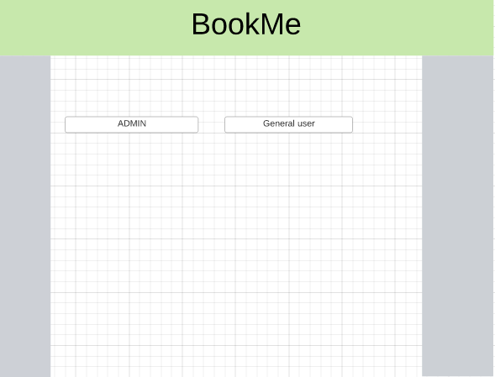

Login Screen – This is concensional way, we shall have it as a popu up or anything as we like

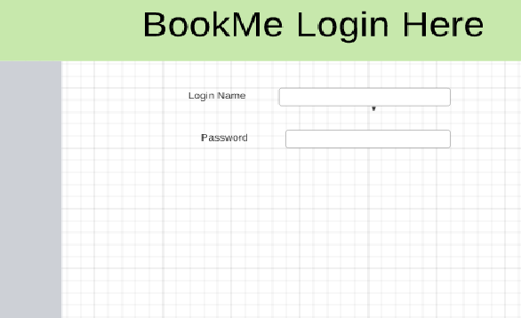

**2 - User landing page**

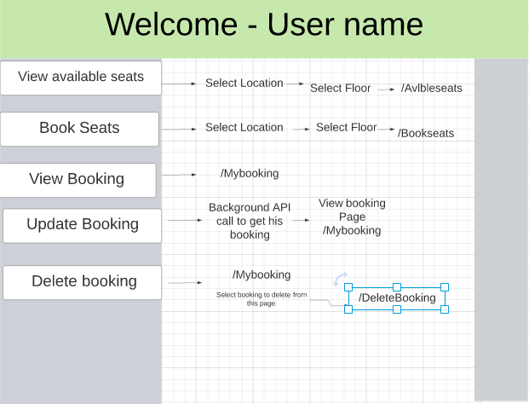

**3 - Admin landing page**

